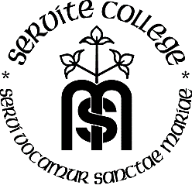
Servite Catholic College
Year 12 General English
Semester 1 (Term 1)
Task 6
Type of Assessment Creating
In-Class & Home Group creation of magazine
Weighting 15%

Due: Week 10

Task
In groups of not more than four you will work together to create a special interest media source such a magazine, newspaper or website. This source will be complete with target audience appropriate stories and advertisements.

Assessment Conditions
- You will have approximately 4 class periods to work on this in class but are expected to work on it at home
- Final product must be of a high standard
- Techniques and conventions of both visual and print must be adhered to
- Content of the media source must be original although you are permitted to use technology where appropriate

Description | Marks
Article | 1-10
Creates interesting and original articles to suit target audience and special interest of the media source
Advertisements | 1-10
Creates appropriate advertisements to suit target audience and special interest of the media source
Applies all techniques appropriate for advertising such as font, colour and misc-en-scene
Writing skills | 1-10
Constructs articles and written codes in advertisements using appropriate techniques and conventions of each genre
Total | /30

Teacher Comment

STUDENT DECLARATION
I declare that the attached work is solely my own and is the result of my researching, planning and application.

STUDENT SIGNATURE_____________________________________________________

STUDENT NAME____________________________________________________________

